**Title of project**:Recommending geographical proximity for geolocational data using machine learning techniques.

**Brief description**:

The traditional approaches for investigating human mobility behaviors in big cities usually include time consuming and costly observations and questionnaires. Since then, Recommendation System (RS) has gained popularity for modelling human movements in different research contexts. Analyzing geo-locational data offers valuable insights into regional human behaviour and preferences.Geographical analysis of geo-located data provides useful information about regional human behaviour and choice tendencies. Nowadays, it is very important to find a convenient location which would meet all requirements of a person at affordable price.This project leverages data visualization and clustering techniques to identify such places within a given radius, considering parameters like cafe,gym,park,hospital,bus stop,movie theatre,hotel.Within a given radius, places characterised by parameters such as cafes, gyms, parks, hospitals, bus stops, movie theaters, and hotels are identified through the utilisation of data visualisation and clustering techniques in this project. Geo-locational data, acquired from the Here Geocoding and Search API v7, undergoes K-Means Clustering for grouping. This clustering is applied to the geo-locational data, allowing the categorization of accommodation based on user preferences for amenities. Intelligent user suggestions are generated by the Machine Learning model, which analyzes both geo-locational data and user preferences. The overarching objective is the classification of locations into categories of rich, average, and low amenities, with the results presented on a map for user-friendly comprehension and decision-making.

**Objectives:**

1.Implement a comprehensive data preprocessing pipeline to clean and enhance the quality of geolocation data, addressing issues like inconsistencies, outliers, and missing values.

 2.Incorporate state-of-the-art clustering algorithms, such as K-means to effectively categorise geolocation data into meaningful clusters.

3.Design an intuitive and interactive Geo-location map interface that allows users to visually explore and interpret identified clusters effortlessly.

4. Develop tools that enable users to dynamically visualise and explore clusters on the Geo-location map, allowing for a deeper understanding of spatial patterns.

**Outcomes**:

1.Users benefit from a clear and concise categorization of accommodations, facilitating informed decision-making based on amenities, contributing to a more confident selection process.

2.The clustering algorithm streamlines the accommodation search, allowing users to focus on specific clusters of options aligned with their priorities, leading to a more efficient and targeted search experience.

3.The project's analysis of regional human behavior provides valuable insights for local authorities and accommodation providers, enabling optimized resource allocation, infrastructure development, and tourism planning based on specific amenities in demand within different clusters.

**Photograph of Working Model:** (For Model Based projects)

1. Understanding the feature count visually on map.

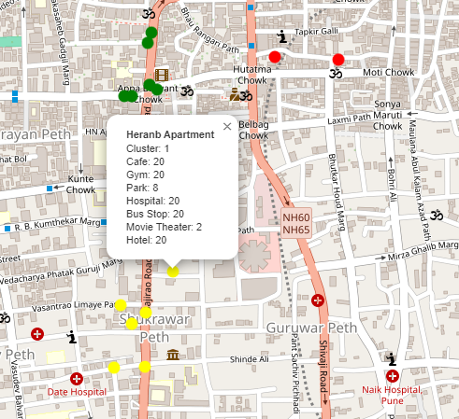

2.Visulation Analysis of distance beweten data points

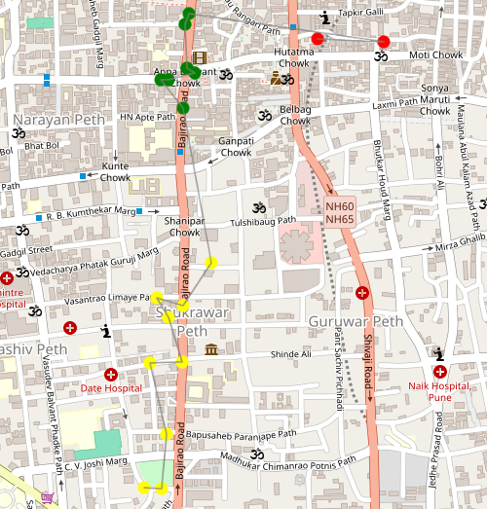

3.Actual distance to reach from one apartment to another

